**Exp. No.: 21**

**MYSQL STRING FUNCTIONS- SPACE, SUBSTR, UPPER, LOWER, TRIM, LENGTH**

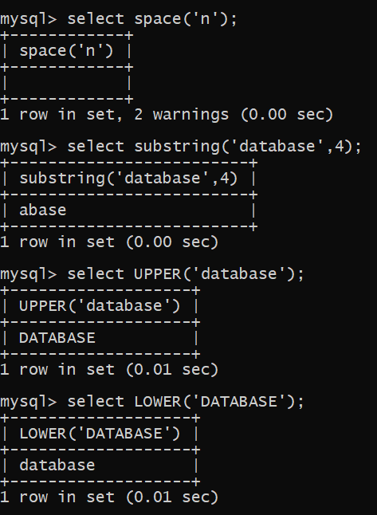

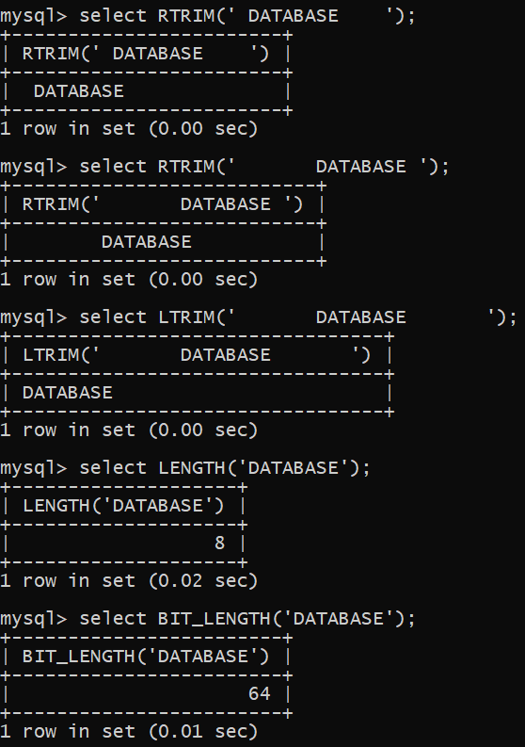

**RESULT**

Thus the String Functions such as space, substr, upper, lower, trim, length are executed successfully